Lab – Setting Up the Lab Environment (Instructor Version)

**Instructor Note**: Red font color or gray highlights indicate text that appears in the instructor copy only.

1. Objectives

Part 1 (Option 1): Import the VirtualBox VM with Cisco IOS-XE

Part 1 (Option 2): Set Up a Cisco ISR4k Router with Cisco IOS-XE

Part 1 (Option 3): Set Up a DevNet Sandbox Reservation with Cisco IOS-XE

Part 2: Summary and Connection Details

1. Required Resources

* For Part 1 Option 1:
  1. Host computer with at least 4 GB of RAM and 15 GB of free disk space
  2. Oracle VirtualBox
* For Part 1 Option 2:
  1. Host computer with at least 2GB of RAM
  2. Cisco ISR4221 or ISR4321 router with IOS-XE version 16.6 or above
* For Part 1 Option 3:
  1. Host computer with at least 2GB of RAM
  2. Internet Connectivity

# Instructions

1. (Option 1) Import the VirtualBox VM with Cisco IOS-XE

Use this option if you do not have access to physical routers capable of running the Cisco IOS-XE operating system such as those in the official NetAcad bundles (the ISR4221 routers, etc.). In this option, the Cisco IOS-XE is running in a virtual machine (VM) directly on your x86 computer and requires at least 4GB of RAM.

* + 1. Download the VM OVA file.

1. Go to the Workshop class on NetAcad.com and navigate to the page 1.0.1.2: Lab - PC Setup for Workshop.
2. Download the Ch2 ZIP archive that includes the VirtualBox ETW-CSR1000v.ova file with the Virtual Machine template.
3. Import the OVA file into your VirtualBox environment. While importing the OVA file, do not change any parameters in the virtual HW configuration:
4. In the directory of the Virtual Machine (e.g. c:\Users\USER\VirtualBox VMs\ETW-CSR1000v) replace the "csr1000v-universalk9-install.iso" ISO file, with the CSR1000v ISO file downloaded from software.cisco.com (e.g. csr1000v-universalk9-XX.XX.XX.iso).  
   **Note**: Only instructors with a valid Academy Maintenance contract can download files from software.cisco.com.
5. Start the VM and let it boot for the first time.   
   **Note**: If you see the “Interface ('VirtualBox Host-Only Ethernet Adapter') is not a Host-Only Adapter interface (VERR_INTERNAL_ERROR).” error message, select the VM’s Settings -> Network -> Host-only Adapter and click OK.  
   During the first boot, the CSR1000v ISO file is used to install and set up the VM with the Cisco IOS-XE software. The installation takes about 5-7 minutes to complete. Please be patient and ignore the warning or error messages that might appear on the screen during the installation process.
6. When the installation has been completed, the VM will restart and release the ISO file. You can then delete the "csr1000v-universalk9-install.iso" file to free up disk space.
7. The initial boot of the VM with Cisco IOS-XE takes about 2-3 minutes. Press the Enter key to execute the command line interface:  
   The VM networking is configured to use the Host-Only network of your host machine.   
   Using the command line interface, enter the “**sh ip int brief**” command to identify the router’s current IP address:

Please take a note of the router’s IP address, for it will be used in the next lab activities.

1. Connect from the host machine to the SSH service of Cisco IOS-XE router in the VM. Use Putty on the host machine to connect to the IP address of the VM:
2. The VM comes with an initial configuration that enables network programmability lab activities. For example, the NETCONF and RESTCONF API interfaces are pre-configured by default.

The default pre-configured privilege 15 level username is **cisco** with the **cisco123!** password.

1. (Option 2) Set Up a Cisco ISR4k Router with Cisco IOS-XE

Use this option if you have physical access to an ISR4221 router in your academy’s lab kit. With this option, you can experiment using network programmability APIs with real routers.

* + 1. Verify the IOS-XE requirements on the ISR4221 router.

1. Using CLI access to your ISR4221 router, verify using the “**show version**” command, if the currently running IOS-XE version is at least 16.6.1.
2. If the currently running IOS-XE version is less than 16.6.1, before continuing, upgrade the Cisco IOS-XE version on your router.   
   **Note**: Instructors with active NetAcad Maintenance contract can download IOS updates for ISR4221 routers from <https://software.cisco.com/download/home/286310700/type/282046477> .
   * 1. Enable programmable API interfaces on the ISR4221 router.
3. Configure the GigabitEthernet1 interface with an IP address that is reachable within the lab topology from your computer. An example is this simple topology below:

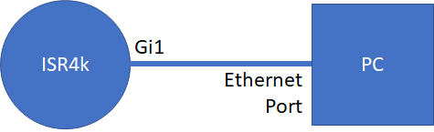

The configuration on the ISR4221 router could be:

interface GigabitEthernet1

description Link to PC

ip address 192.168.1.1 255.255.255.0

no shutdown

The computer could be configured with the 192.168.1.2/255.255.255.0 IP address.

1. Verify that you can ping the router’s IP address from your computer.
2. Configure the router to enable the NETCONF and RESTCONF API interfaces as shown below:

hostname ISR4k

ip domain-name etw.netacad.com

crypto key generate rsa modulus 2048

username cisco priv 15 pass cisco123!

netconf-yang

restconf

ip http secure-server

ip http authentication local

line vty 0 15

login local

transport input ssh

1. The table below summarizes the network services and their respective port numbers running on the ISR4221 router:

|  |  |
| --- | --- |
| **Service Name** | **Port on the ISR4221 router** |
| SSH | 22 |
| HTTP | 80 |
| HTTPS | 443 |
| NETCONF | 830 |

1. Connect from your computer to the SSH service of Cisco IOS-XE on the ISR4221 router. Use Putty on your computer to connect to the IP address of your ISR4221 router on port 22:
2. As per the configuration from above, the default pre-configured privilege 15 level username is **cisco** with the **cisco123!** password.
3. (Option 3) Set Up a DevNet Sandbox Reservation with Cisco IOS-XE

Using this option, you can create your own remotely-accessible, virtualized Cisco IOS-XE device in the DevNet Sandbox. To access the sandbox environment, first create a Sandbox reservation for a specific timeslot. Then using the Cisco AnyConnect VPN client, connect to the remote DevNet Sandbox.

* + 1. Create a DevNet Sandbox reservation.

1. Visit <https://devnetsandbox.cisco.com>
2. Login using the NetAcad login option.
3. Search for the IOS XE Programmability NETCONF-RESTCONF-YANG sandbox shown below:

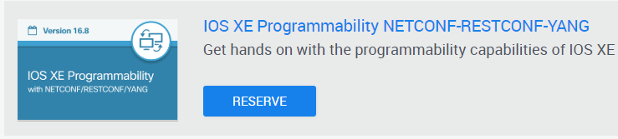

1. Click the Sandbox Title or follow the direct link below: <https://devnetsandbox.cisco.com/RM/Diagram/Index/27d9747a-db48-4565-8d44-df318fce37ad?diagramType=Topology> to enter the sandbox details:
2. Click the RESERVE button. On the next screen adjust the SCHEDULE section with date and time when you want to play with the Sandbox environment.
3. After creating a new Sandbox reservation, you should immediately receive an email notification confirming the reservation. In the email notification, you will receive instructions on how to download and use the Cisco AnyConnect VPN client to connect to the remote Sandbox environment.
4. Please allow up to 30 minutes for the Sandbox reservation system to send you the final email notification with the specific connection details (VPN remote host, username, password, etc.):
   * 1. Connect to the DevNet Sandbox reservation using VPN.
5. With your VPN credentials from the email, use the Cisco AnyConnect VPN client to connect to the remote DevNet Sandbox environment:
6. When you are connected to the VPN, you should be able to ping the Cisco IOS-XE router’s IP address: 10.10.20.48
7. The table below summarizes the network services and their respective port numbers running on the remote Cisco IOS-XE router:

|  |  |
| --- | --- |
| **Service Name** | **Port on the ISR4221 router** |
| SSH | 22 |
| HTTP | 80 |
| HTTPS | 443 |
| NETCONF | 830 |

1. Connect your computer to the SSH service of Cisco IOS-XE on the remote router. Use Putty to connect your computer to the 10.10.20.48 IP address of the router to port 22:
2. The Cisco IOS-XE router in the DevNet Sandbox comes with an initial configuration that enables network programmability lab activities. For example, the NETCONF and RESTCONF API interfaces are pre-configured by default. The default pre-configured privilege 15 level username is **cisco** with the **cisco_1234!** password.
3. Summary and Connection Details

The lab activities were designed with the “Local Virtual Machine with IOS-XE” option.   
If you are using one of the other lab equipment options, adjust the hostname or the IP address and the port of the IOS-XE router accordingly in the lab activities. Use the table below as a reference:

|  |  |  |  |
| --- | --- | --- | --- |
|  | **Local VM with IOS-XE** | **DevNet Sandbox** | **Local ISR4221 Router** |
| **Hostname/IP address** | The IP address of the ETW-CSR1000v VM. Usually 192.168.56.101. Check using the “**sh ip int brief**” command on the VM’s console. | 10.10.20.48 | Any IP address configured on the ISR4k router reachable from your computer. |
| **Ports** | SSH: 22  NETCONF: 830  RESTCONF: 443 | SSH: 22  NETCONF: 830  RESTCONF: 443 | SSH: 22  NETCONF: 830  RESTCONF: 443 |
| **Credentials** | L: cisco P: cisco123! | L: cisco P: cisco_1234! | L: cisco P: cisco123! |

Here are some examples of required changes (replace “192.168.56.101” and if needed, also the username and password options:):

* 1. Lab 2.2 Part 2c:

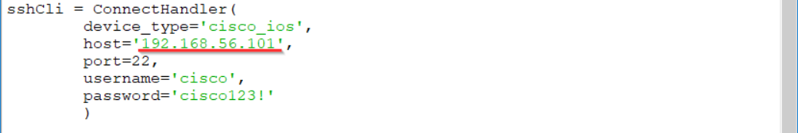

* 1. Lab 2.4 Part 1 Step 2b:



* 1. Lab 2.5 Part 1 Step 2:



End of Document